# Knowing what workers want

One size does not fit all when it comes to attracting and retaining talent. What people seek from their place of work is entirely unique to them, often influenced by age, life stage, and career and personal goals.

The profiles below suggest the stated desires and interests of three employee segments: women, frontline workers and knowledge workers. Note the similarities and differences between the 3.



| **Women** | | | |
| --- | --- | --- | --- |
| Research from Potential Project found that in the first year of the pandemic alone, 54 million women around the world left the workforce, almost 90 percent of whom exited the labour force completely. The participation rate for women in the global labour force is now under 47%, drastically lower than men at 72%. Opportunity awaits employers who are willing to tap into this market. Women are most likely to seek and respond to the following: | | | |
| **CONTROL OF THEIR WORKDAY** | **FLEXIBLE WORK PENALTIES** | **COMPASSIONATE MANAGERS** | **CULTURE** |
| Women want control over when, where and how their work is completed. They are10% more likely than males to look for and accept roles where they can work flexibly. | Women want their employers to play a more active role in helping them to progress without paying a flexible work tax (where career progress stalls when one elects to work part time.) | Women (more so than other cohorts)desire compassionate managers who understand the need for flexibility, wellbeing supports, and take action to help manage burnout. | Toxic cultures have been the number one factor identified in influencing women to leave their places of work. |

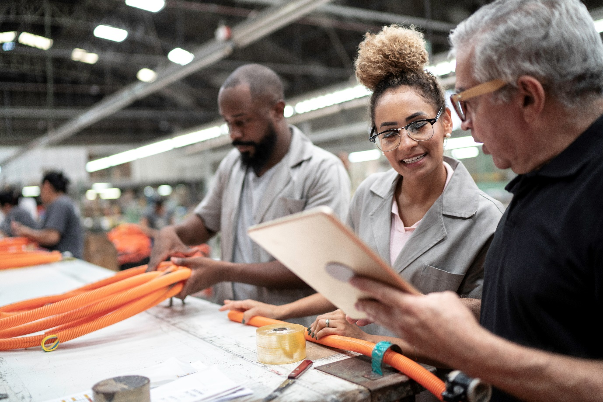

| **Knowledge Workers** | | | |
| --- | --- | --- | --- |
| Research has shown that productivity for knowledge workers rose by 30% during the pandemic, a spike which came with a cost. The blurring of boundaries between home-life and work-life increased feelings of fatigue and burnout. The pandemic also introduced a new level of flexibility and autonomy, cementing hybrid work as an expectation. Knowledge workers are most likely to seek and respond to the following: | | | |
| **SUPPORTIVE COWORKERS** | **WORK LIFE INTEGRATION** | **FLEXIBILITY** | **REMUNERATION** |
| Knowledge workers wish to work alongside talented co-workers and supportive managers. | This cohort have increased their focus on work life balance. On average, employee job satisfaction decreases as they work greater hours per week. | Knowledge workers are seeking more autonomy over their working day, including where, when and how work is completed. | This cohort wish to ensure that remuneration is commensurate with the rising cost of living and capabilities they bring to the role. |



|  |  |  |  |
| --- | --- | --- | --- |
| **Frontline Workers** | | | |
| Frontline workers were at the coal face of the pandemic, risking their personal safety while many others stayed at home. Research from consulting firm, Accenture, has found at least three quarters of frontline workers feeling anxious, overwhelmed or frustrated. Frontline workers are most likely to seek and respond to the following: | | | |
| **REMUNERATION** | **HEALTH & HYGIENE** | **CULTURE** | **DIVERSITY AND INCLUSION** |
| Frontline workers are motivated by pay and ensuring this is commensurate with the rising cost of living. | This cohort want to work in organisations which promote the safety, health and wellbeing of employees. | Frontline workers place significant importance on culture and team dynamics. | Frontline workers are seeking a strong commitment to wellbeing, diversity, equity and inclusion. |